RESEARCH REPORT STRUCTURE
- Cover Page: (Program title, course code, course title, and intake), assessment type, assessment title (different from the research question), student name, and student id and submission date. Page number must start at the first page of your report.
- Contents.
- Title: Your title has to be different from your research question.
- Abstract: this section must include the idea, question, aims, method, and brief about results.
- Keywords: Please do not confuse between subject areas and keywords that have to be aligned with the UAE context.
- Introduction:
You must start by analyzing your interest when you initially thought about this topic (existing challenge or innovative idea) and how you have reached the final version of your research question. You will have to demonstrate that your topic is feasible and worthwhile.
After writing your research objectives (that will be mapped later with your results/ findings and conclusion), you have to define key concepts that will better locate your topic in theory, and introduce your research question.
At this level, you may start applying the “research onion” especially how you have decided your research assumptions, philosophy and your approach to theory development.
- Literature review:
As per the research process, you will have to specify which review type and critic approach you have decided to use and apply in your individual report.
The depth of knowledge, terminology, concepts, and theoretical debate are key elements in this section.
You will have to use ranked academic journals, textbooks and resources specific to the UAE when available to show your rational thinking. Do not forget to include in appendix section screenshots about results.
- Research Methodology and Strategy:
This section includes methodological choice and research strategy. You will justify how the selected method, type of collected data (secondary vs. primary), calculation of sample size, and analysis tool (to be linked with the excel file) are suitable to the topic.
- write area cover by question Y and X , example in book-Page 515
- will start secondary Research and then primary Research
- Sample size number should be in Abstract session but sample size equation + applicable should be under Methodology session (example in book-Page 732).
- Regression analysis can be table a part of document.
- Data analysis and results:
This section must include main tables, figures, and results from your data analysis tool (for example regression, K.S. Test, etc.) and how you link results to accept or reject hypotheses.
- Discussion:
This section must explicitly give evidences on how you are relating results to initial idea and research question.
- Recommendation ( Your recommendations to organizations, institutions, and industries in the UAE context are essential.
- Conclusion: You have to give clear answer(s) to your research question(s) and open your topic to further research efforts in the future.
- Appendices: It is recommended to include research onion, research process, Gantt chart, results from excel or data analysis software, screenshots from EBSCO, etc.
- References: Please write few words on the style that you have decided when writing your references (e.g. APA or Harvard)

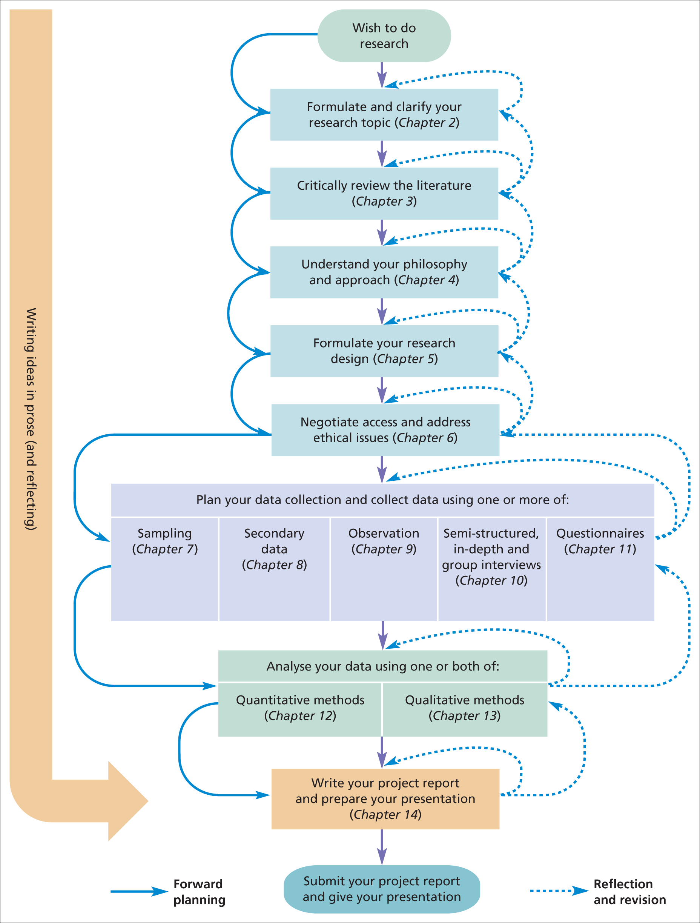
Picture 1: The research process:

Picture 2: The research ‘onion’:

